1.

package io;

import java.nio.file.FileSystem;

import java.nio.file.FileSystems;

import java.nio.file.Path;

public class PathResolver {

public static void main(String[] args) {

FileSystem fileSystem = FileSystems.*getDefault*();

Path path = fileSystem.getPath("C:/JavaProgramming/employees.txt");

System.***out***.println("Resolved Path: " + path.toString());

}

}

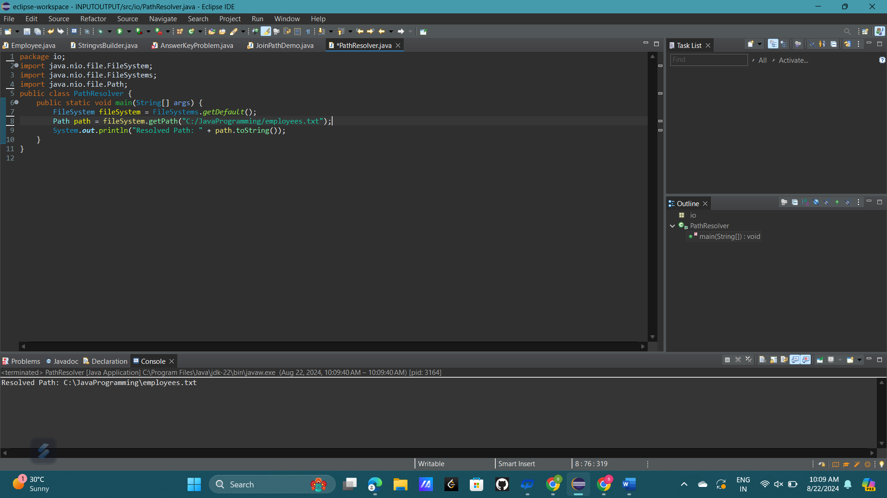

2.

The java.io package has several limitations:

1. **Blocking I/O**: The java.io package uses blocking I/O, which means that when a thread performs an I/O operation, it blocks until the operation is completed, potentially leading to inefficiency, especially in high-concurrency environments.
2. **Lack of Non-Blocking/NIO Capabilities**: The package lacks support for non-blocking I/O operations, which is essential for scalable, high-performance applications.
3. **Limited Buffering**: While classes like BufferedReader and BufferedWriter offer basic buffering, the java.io package lacks advanced buffer management options that are available in java.nio.
4. **No Support for Memory-Mapped Files**: The package doesn’t support memory-mapped file I/O, which allows files to be mapped directly into memory, offering significant performance improvements for large files

3.

package io;

import java.io.File;

import java.io.FileReader;

import java.io.BufferedReader;

import java.io.IOException;

public class FileReadingExample {

public static void main(String[] args) {

String filePath = "C:/JavaProgramming/employees.txt";

File file = new File(filePath);

if (!file.exists()) {

System.***err***.println("File not found: " + filePath);

return;

}

BufferedReader reader = null;

try {

FileReader fileReader = new FileReader(file);

reader = new BufferedReader(fileReader);

String line;

while ((line = reader.readLine()) != null) {

System.***out***.println(line);

}

} catch (IOException e) {

System.***err***.println("Error reading the file: " + e.getMessage());

} finally {

if (reader != null) {

try {

reader.close();

} catch (IOException e) {

System.***err***.println("Error closing the reader: " + e.getMessage());

}

}

}

}

}

